Project Documentation

1. Title: AI-AgroBot: Universal AI-based Agricultural Assistant

Prepared By: Tanvi Khicchi
Internship: Infosys Springboard – Full Stack Development

2. Project Statement
The AI-AgroBot is an intelligent web-based agricultural assistant designed to help farmers monitor crop health, detect diseases, and receive real-time insights using AI-powered image analysis.
It aims to simplify farm management by combining an AI chatbot, image recognition, and admin dashboards for managing users and knowledge bases.
This assistant provides region-specific, crop-specific, and multilingual responses to farmers’ queries—making smart agriculture accessible to everyone.

3. Outcomes
- AI-driven analysis of crop images to detect stress or diseases.
- Real-time text or voice-based chatbot support for farmers.
- Personalized recommendations based on the user’s crop, region, and preferred language.
- Admin dashboard to manage users, chat history, and knowledge base.
- Scalable modular system that integrates AI, databases, and web technologies.

4. Modules to be Implemented
Module | Description
User Authentication | Login, Signup, and Role-based access (Farmer/Admin).
Chatbot Assistant | AI-powered chatbot with multilingual support for agricultural FAQs.
Image Analysis | Upload crop images to detect health, disease, or stress conditions using AI model integration.
Profile Management | Users can update crop, region, and language preferences.
Admin Dashboard | Manage farmers, delete users, and update the Knowledge Base (KB) using CSV upload.
Recent Conversations | Admin can view, track, and manage chat logs with timestamps and responses.
Database Integration | Store user data, KB entries, and chat history in the backend database.

5. Architecture Diagram

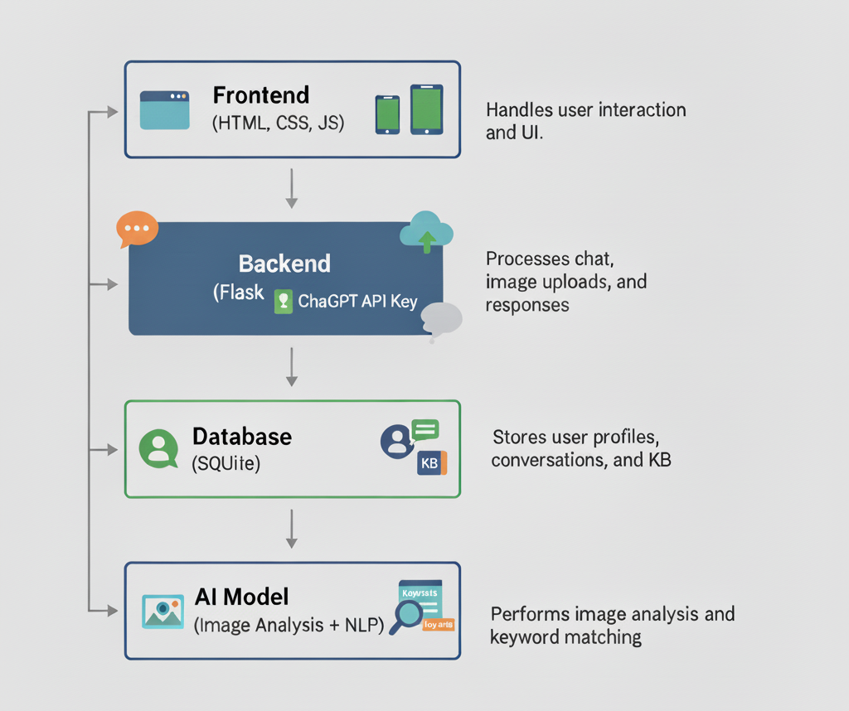
- The frontend handles user interaction and UI.
- The backend processes chat, image uploads, and responses.
- The database stores user profiles, conversations, and KB.
- The AI model performs image analysis and keyword matching.

6. Database Schema
Table | Fields | Description
users | id, name, email, password, role, crop, region, language | Stores user info (farmers and admin).
knowledge_base | id, keywords, answer_en, answer_hi, answer_ta | Holds multilingual chatbot knowledge.
chat_history | id, user_id, message, reply, timestamp | Logs all conversations.
images | id, user_id, image_path, analysis_result | Stores uploaded images and AI analysis output.

7. Conclusion
AI-AgroBot successfully combines AI, agriculture, and automation to empower farmers with data-driven insights.
By integrating chat, image recognition, and admin controls into a unified system, it improves farming efficiency, promotes sustainable practices, and supports precision agriculture.
This project serves as a prototype for scalable AI solutions in the AgriTech domain.

8. Sample Code

🔹 Frontend (HTML + CSS)

{% extends "base.html" %}
{% block content %}
<div class="container">
<aside class="sidebar">
<h3>Your profile</h3>
{% if current_user.is_authenticated %}
<p><strong>{{ current_user.name or current_user.email }}</strong></p>
<p>Crop: {{ current_user.primary_crop or "—" }}</p>
<p>Region: {{ current_user.region or "—" }}</p>
<p>Lang: {{ current_user.preferred_language or "en" }}</p>
<a class="btn" href="{{ url_for('profile') }}">Edit profile</a>
{% else %}
<p><a href="{{ url_for('login') }}">Login</a> to save chat & see profile.</p>
{% endif %}
{% if recent_users %}<hr><h4>Recent users (admin)</h4><ul class="user-list">{% for u in recent_users %}<li><a href="{{ url_for('admin_view_user', user_id=u.id) }}">{{ u.email }} - {{ u.name or '—' }}</a></li>{% endfor %}</ul>{% endif %}
</aside>
<section class="chat-panel">
<div id="messages" class="messages" aria-live="polite"></div>
<form id="chatForm" class="chat-form" onsubmit="return false;">
<input id="msg" aria-label="Type your question" placeholder="Ask about crops, pests or soil (e.g. 'best soil for cotton')" autocomplete="off">
<!-- Image Upload Button - properly connected to hidden file input -->
<label for="imageInput" class="btn" style="cursor: pointer;" title="Upload Image for Analysis">
📷 Image
</label>
<input type="file" id="imageInput" accept="image/*" style="display: none;">
<!-- Voice Input Button -->
<button id="voiceBtn" type="button" class="btn" title="Voice Input">🎤 Voice</button>
<!-- Send Button -->
<button id="sendBtn" type="button" class="btn">Send</button>
</form>
</section>
</div>
{% endblock %}

:root {
--brand: #2563eb;
--muted: #6b7280;
--bg: #f3f4f6;
--card: #ffffff;
}
* {
box-sizing: border-box;
}
body {
font-family: Inter, system-ui, Segoe UI, Roboto, Arial;
margin: 0;
background: var(--bg);
color: #111;
}
.topbar {
display: flex;
align-items: center;
justify-content: space-between;
padding: 14px 20px;
background: var(--card);
box-shadow: 0 2px 6px rgba(0, 0, 0, 0.06);
}
.brand {
display: flex;
align-items: center;
gap: 12px;
}
.logo {
width: 48px;
height: 48px;
border-radius: 10px;
}
.nav a {
margin-left: 14px;
color: var(--muted);
text-decoration: none;
}
.main {
max-width: 1100px;
margin: 28px auto;
padding: 0 18px;
}

🔹 Backend (Python Flask)

import os, json, re
from typing import Dict, Any
from langdetect import detect, DetectorFactory
# Fix langdetect seed for consistency
DetectorFactory.seed = 0
# Google Translate setup
try:
from googletrans import Translator
TRANSLATOR = Translator()
HAS_GOOGLETRANS = True
except Exception:
TRANSLATOR = None
HAS_GOOGLETRANS = False
# --- OpenAI setup ---
OPENAI_API_KEY = os.getenv("OPENAI_API_KEY")
HAS_OPENAI = False
if OPENAI_API_KEY:
try:
from openai import OpenAI
client = OpenAI(api_key=OPENAI_API_KEY)
HAS_OPENAI = True
except Exception as e:
print("⚠️ OpenAI import failed:", e)
HAS_OPENAI = False
# --- Load Knowledge Base ---
KB_PATH = os.path.join(os.path.dirname(__file__), "kb.json")
def load_kb():
if not os.path.exists(KB_PATH):
return {}
with open(KB_PATH, "r", encoding="utf-8") as f:
data = json.load(f)
out = {}
if isinstance(data, list):
for entry in data:
keys = entry.get("keywords") or []
if isinstance(keys, str):
keys = [k.strip() for k in keys.split(",") if k.strip()]
for k in keys:
out[k.lower()] = {
"en": entry.get("answer_en", ""),
"hi": entry.get("answer_hi", ""),
"ta": entry.get("answer_ta", "")
}
elif isinstance(data, dict):
for k, v in data.items():
if isinstance(v, str):
out[k.lower()] = {"en": v}
elif isinstance(v, dict):
out[k.lower()] = {
"en": v.get("answer_en", ""),
"hi": v.get("answer_hi", ""),
"ta": v.get("answer_ta", "")
}
return out
KB = load_kb()

🔹 Database (SQLite)

import os
from flask_sqlalchemy import SQLAlchemy
from flask_login import UserMixin
from datetime import datetime
from werkzeug.security import generate_password_hash
db = SQLAlchemy()
class User(UserMixin, db.Model):
__tablename__ = "users"
id = db.Column(db.Integer, primary_key=True)
email = db.Column(db.String(200), unique=True, nullable=False)
password = db.Column(db.String(200), nullable=False)
name = db.Column(db.String(100))
role = db.Column(db.String(20), default="farmer")
primary_crop = db.Column(db.String(100))
region = db.Column(db.String(100))
preferred_language = db.Column(db.String(20), default="en")
class ChatHistory(db.Model):
__tablename__ = "chat_history"
id = db.Column(db.Integer, primary_key=True)
user_id = db.Column(db.Integer, db.ForeignKey("users.id"), nullable=True)
user_message = db.Column(db.Text)
bot_response = db.Column(db.Text)
created_at = db.Column(db.DateTime, default=datetime.utcnow)
feedback = db.Column(db.String(20), nullable=True)
def init_db(app):
db_uri = os.getenv("DATABASE_URL", "sqlite:///agrobot.db")
app.config["SQLALCHEMY_DATABASE_URI"] = db_uri
app.config["SQLALCHEMY_TRACK_MODIFICATIONS"] = False
db.init_app(app)
with app.app_context():
db.create_all()
admin_email = os.getenv("ADMIN_EMAIL", "admin@agrobot.com")
admin_password = os.getenv("ADMIN_PASSWORD", "Admin@123")
if not User.query.filter_by(email=admin_email).first():
admin = User(email=admin_email, password=generate_password_hash(admin_password), name="Administrator", role="admin", preferred_language="en")
db.session.add(admin); db.session.commit()
print("Created default admin:", admin_email)

9. Output

1️. User Registration

Description:
Allows new users (farmers) to create an account by entering their details such as name, email, password, and region.
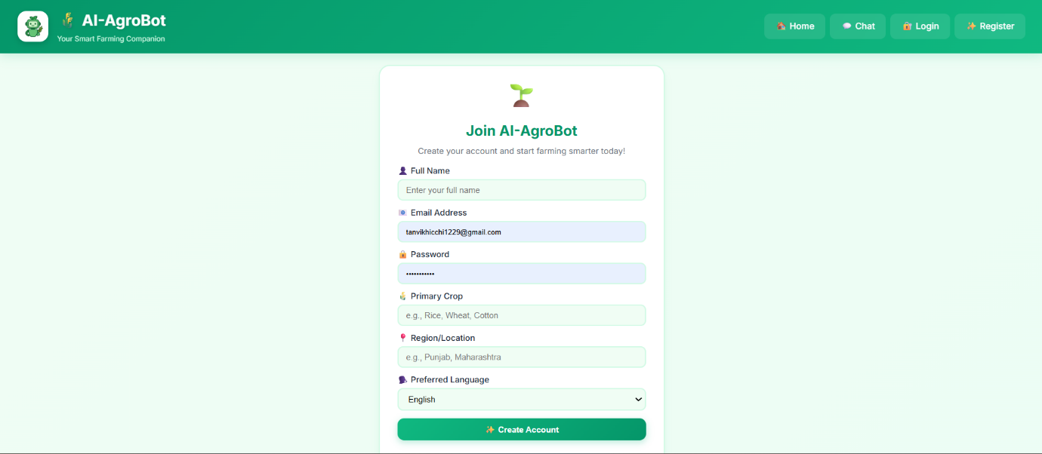

Figure 1: User Registration Page — Displays the registration form for new users to sign up

2️. User Login
Description:
Provides secure access for registered users using email and password authentication.
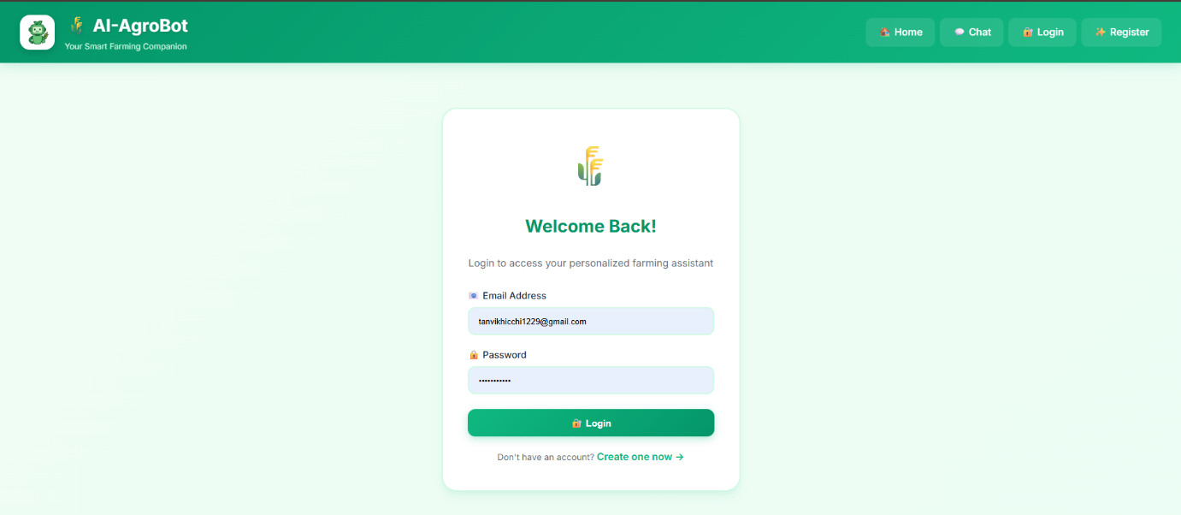

Figure 2: User Login Page — Shows the login interface for returning users.

3️. Dashboard / Home Page
Description:
After login, users are redirected to the main dashboard displaying project details and quick access to features.
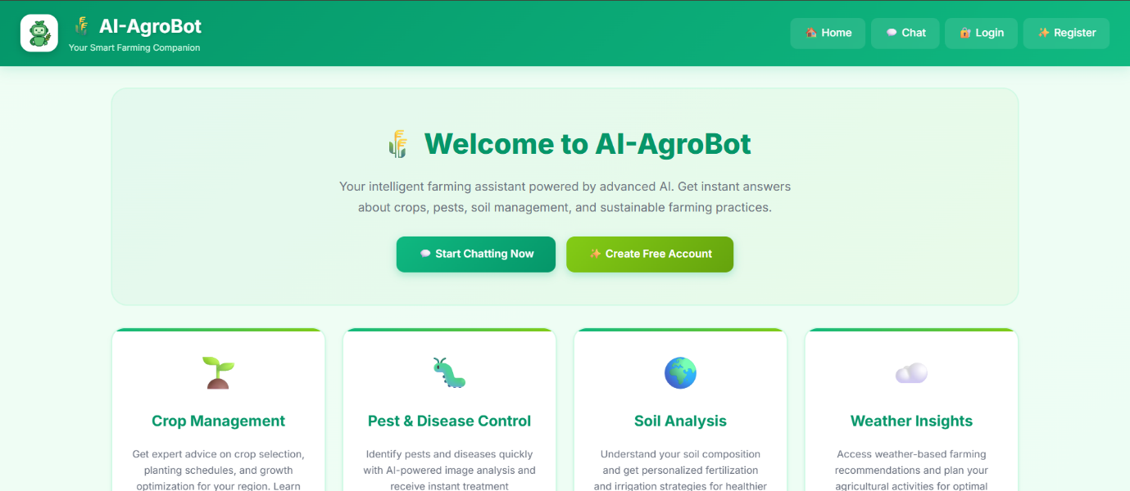
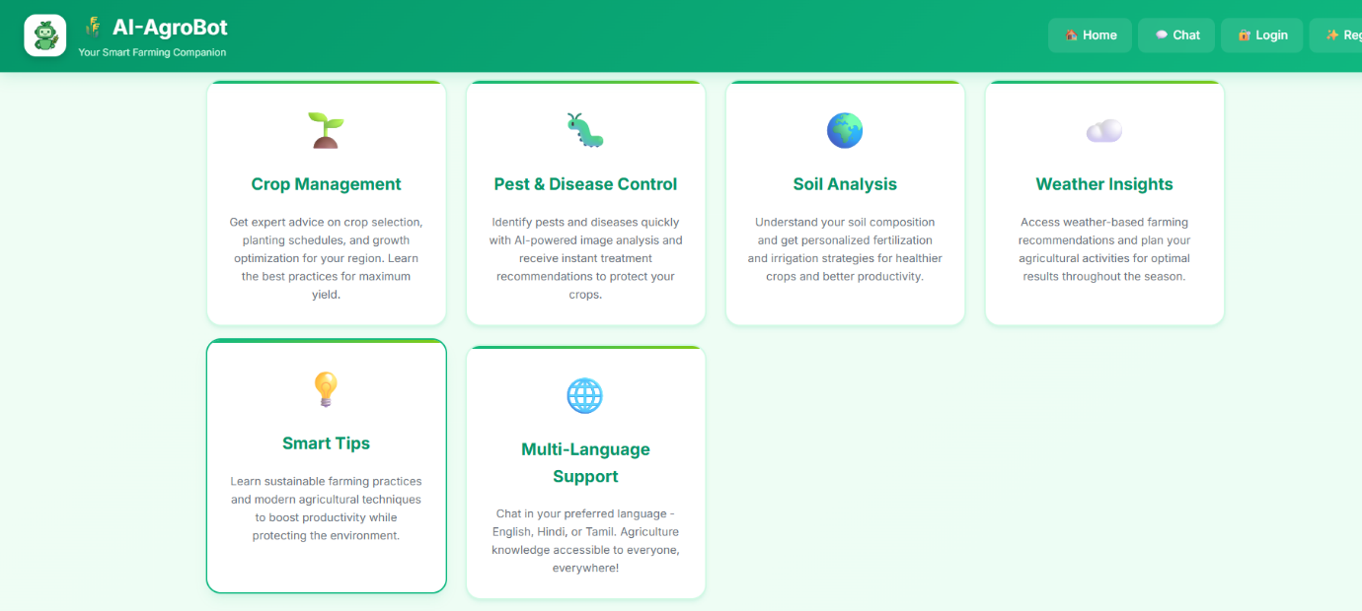
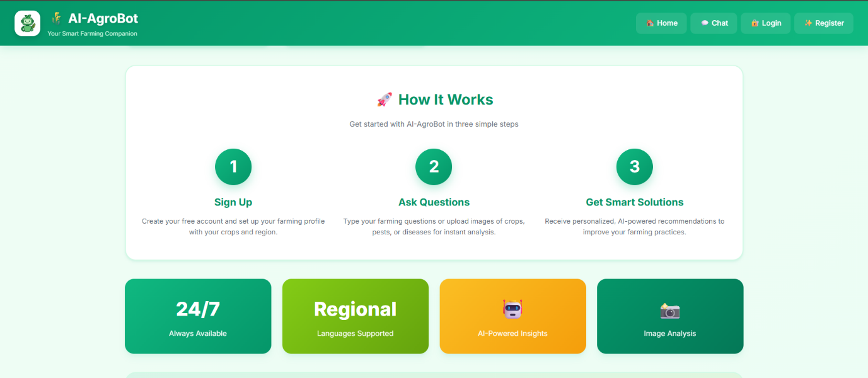
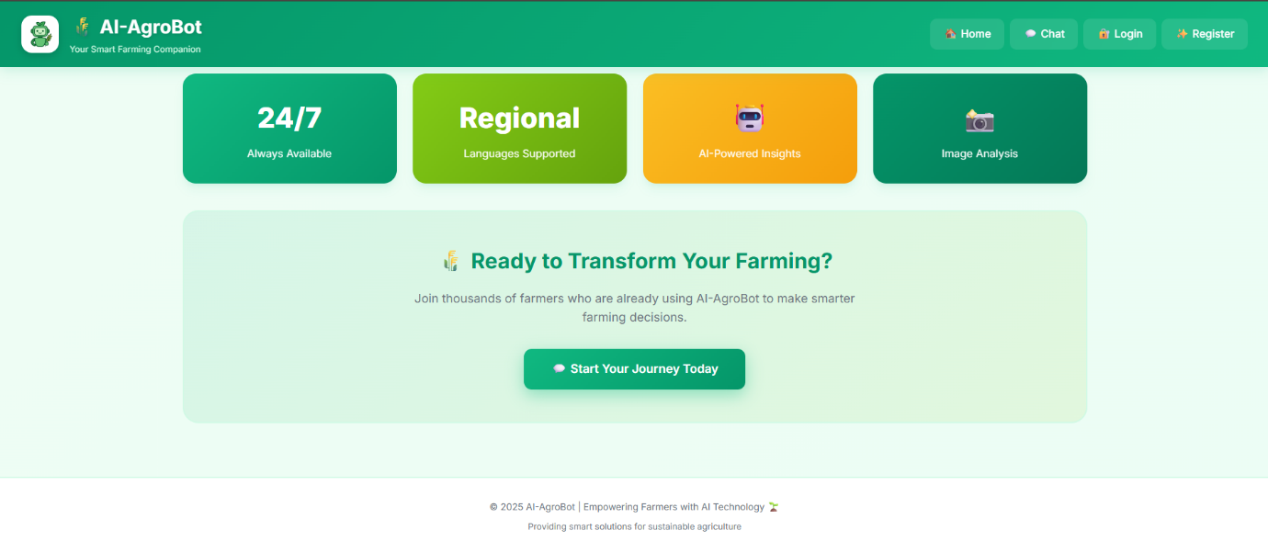

Figure 3: Home Dashboard of AI–AgroBot — Displays the main page with project overview and options.

4️. Edit Profile
Description:
Users can update their name, crop preferences, and other details to receive personalized recommendations.
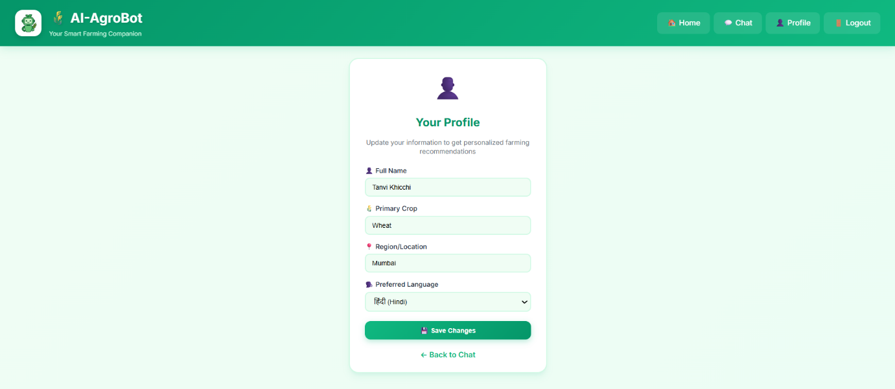

Figure 4: Edit Profile Page — Shows the editable profile interface for farmers.

5️. Chatbot Interaction
Description:
An AI-powered chatbot helps farmers ask queries related to crops, fertilizers, and diseases. It can also analyze uploaded images for disease detection.
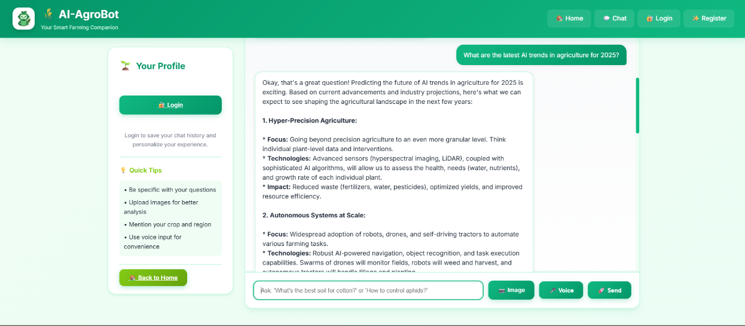
Figure 5: Chatbot Interface — Displays the conversation window for AI-based assistance.

6️. Image-Based Disease Detection
Description:
Users can upload images of crop leaves for AI analysis and receive real-time disease detection and treatment suggestions.
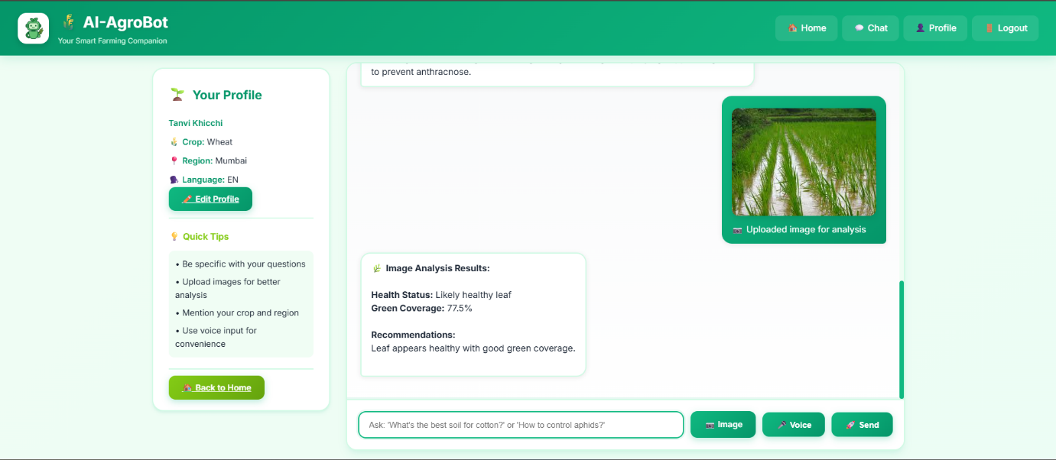
Figure 6: Crop Disease Detection Result — Shows the detected disease with confidence score and recommended solution.

7️. Admin Dashboard
Description:
The admin module allows managing users, monitoring chatbot activity, and updating knowledge base articles.
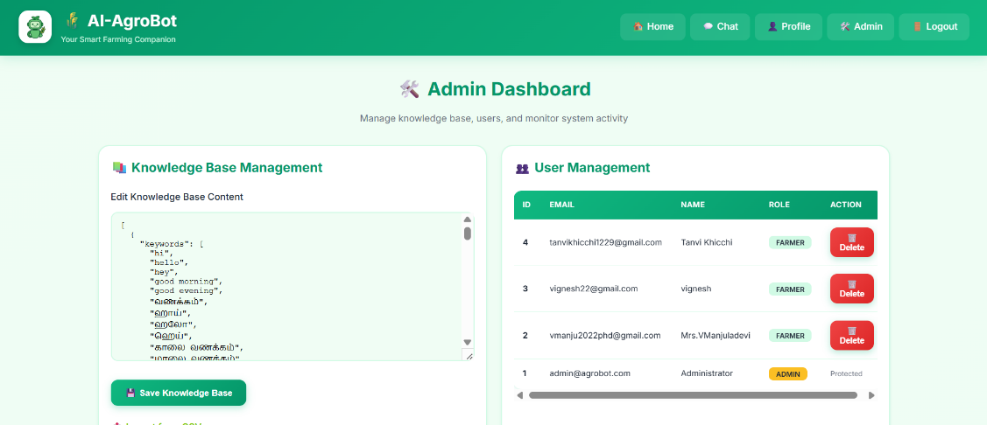
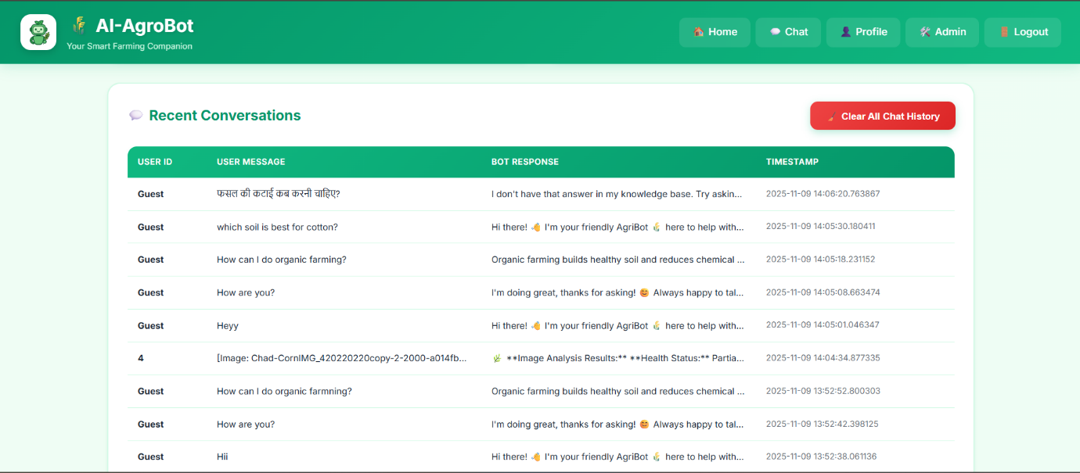
Figure 7: Admin Dashboard — Displays admin functionalities like user management and analytics.

8️. Multilingual Support
Description:
The chatbot and UI support multiple Indian languages to make it accessible to all farmers.
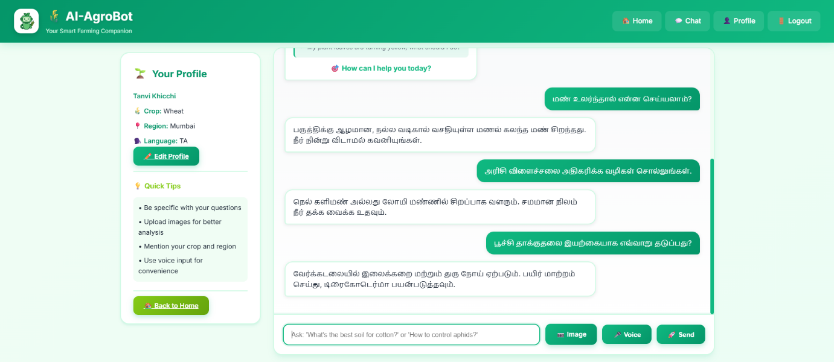
Figure 8: Multilingual Chatbot Interface — Shows example of chatbot responding in Hindi and English.

Submitted by:
Tanvi Khicchi
B.E. Information Technology (2023 – 2027)
Don Bosco Institute of Technology, Mumbai
Internship: Infosys Springboard Artificial Intelligence Domain

